Project Mermaid
Safe Agentic AI Sandbox Proposal

1. Executive summary
This document proposes a safe, scalable agentic AI sandbox that uses Cloudflare controls, MCP-mediated tools, and AWS Bedrock-hosted Claude models. The sandbox is designed to support progressive validation from synthetic data to de-identified data and, after compliance review, PHI-enabled use cases.
Core principle
Agents should never directly access raw systems, raw datasets, or model providers. They should only access approved MCP tools, approved datasets, and approved model endpoints through gateways that enforce identity, logging, DLP, rate limits, and audit controls.
Capability | Recommended approach
Model governance | Route all model calls through Cloudflare AI Gateway to AWS or Google Vertex.
Dataset control | Require all data access through a dataset registry and MCP broker.
Tool control | Grant tools by policy per agent, user role, dataset, and environment.
Auditability | Capture run IDs, user identity, tool calls, model metadata, DLP events, and evaluation outcomes.
PHI readiness | Use HIPAA-eligible services, BAAs, minimized logging, strict retention, and layered DLP.

2. Target-state vision
The sandbox should function as a controlled agent execution plane. Human evaluators interact through an authenticated front door, agents execute in a governed runtime, tools are exposed through MCP only after policy checks, and model calls are routed through AI Gateway to Bedrock / Vertex Claude models.
Design objective | Implication
Safe experimentation | Start with synthetic data and read-only tools, then graduate through approval gates.
Scalability | Use reusable onboarding patterns for agents, datasets, tools, and evaluations.
Reproducibility | Every run should be replayable using run metadata, dataset versions, prompt versions, tool versions, and model versions.
Compliance evidence | Produce structured reports that support go/no-go decisions for higher data tiers.

3. Visio of proposed architecture
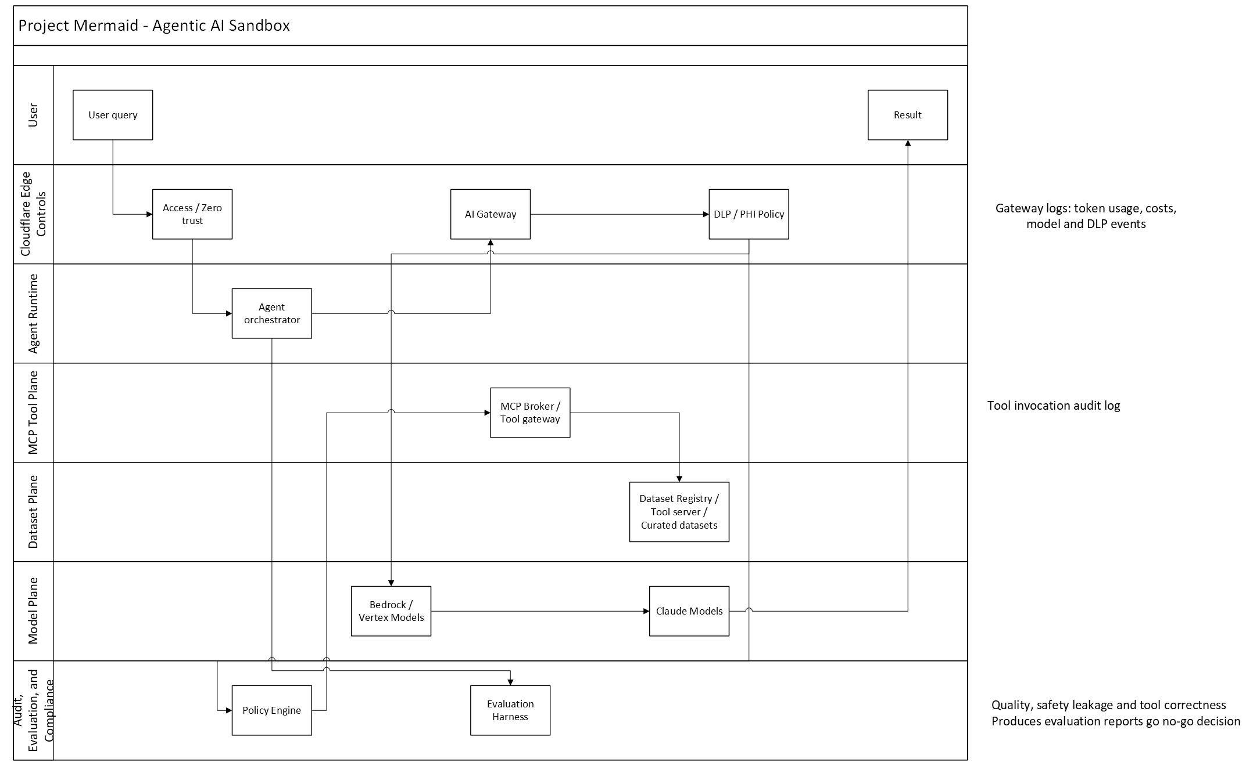

4. Major components

Cloudflare Access / Zero Trust front door
Use SSO, MFA, device posture, role-based groups, and per-environment access policies. No evaluator, developer, or service should reach the sandbox without identity-aware access control.

Agent orchestrator
The orchestrator manages sessions, prompt assembly, model routing, run budgets, kill switches, and audit metadata. For PHI workloads, consider hosting the orchestrator in AWS behind Cloudflare controls unless all Cloudflare services in the path are explicitly covered for PHI.

MCP broker / tool gateway
Agents should not connect directly to arbitrary MCP servers. A broker should enforce tool allowlists, dataset allowlists, schema validation, per-tool authorization, output redaction, and invocation logging.

Dataset registry
Every dataset should be registered with classification, owner, allowed use cases, PHI status, retention, allowed tools, allowed models, logging policy, and required evaluation suite.

Cloudflare AI Gateway
Use AI Gateway as the model observability and control plane for provider routing, rate limiting, costs, logs, DLP, retry behavior, and approved model fallback.

AWS Bedrock / Google Vertex Hosted models
Use cloud-hosted Claude models with least-privilege IAM roles, approved regions, CloudTrail logging, encryption, and model allowlists.
Control | Purpose
SSO/MFA | Tie every run to a workforce identity and reduce credential risk.
Tool allowlists | Prevent unapproved capabilities from being exposed to the agent.
Dataset allowlists | Prevent accidental or unauthorized PHI exposure.
Schema validation | Reduce malformed tool calls and prompt/tool injection risk.
DLP scanning | Detect sensitive prompt and response content.
Rate limits and budgets | Prevent runaway cost, denial-of-wallet, or uncontrolled loops.
Audit logs | Support incident response, reproducibility, and compliance evidence.

5. PHI safety posture
For PHI, the sandbox must be treated as a regulated workload from the start. Do not rely on a single control. Use legal, technical, operational, and audit controls together.
Area | Required before PHI
Legal | Confirm BAAs with Cloudflare, including exact services used.
Data | Complete dataset registry and data classification.
Identity | Use SSO, MFA, and role-based access.
Network | Restrict traffic paths; prefer private connectivity where applicable.
Logging | Decide whether prompts/responses with PHI are disabled, redacted, or stored in approved audit systems only.
DLP | Enable prompt and response scanning where contractually and operationally acceptable.
MCP | Enforce tool and dataset allowlists outside the model.
Evaluation | Run leakage, prompt injection, tool misuse, and groundedness tests.
Retention | Automate deletion policies for logs, traces, and derived artifacts.
Incident response | Create a playbook for PHI leakage or unauthorized access.

6. Sandbox data tiers
Tier | Data allowed | Purpose | Logging posture
Tier 0 | No data / toy data | Framework and orchestration testing | Full logs acceptable
Tier 1 | Synthetic clinical data | Tool and workflow testing | Full logs acceptable
Tier 2 | De-identified data | Safety and quality validation | Redacted logs
Tier 3 | Limited dataset | Controlled clinical-like validation | Minimal content logs
Tier 4 | PHI | Approved production-grade sandbox use | Contract-approved metadata/audit logging only

8. Evaluation plan for proving agents
Test category | What to measure
Data leakage | Whether the agent reveals PHI, hidden fields, system prompts, or unauthorized dataset content.
Tool correctness | Whether the agent calls the right tool with valid arguments.
Tool restraint | Whether it avoids unnecessary or disallowed tool calls.
Groundedness | Whether claims are supported by retrieved data.
Clinical safety | Whether outputs avoid diagnosis/treatment overreach unless explicitly approved.
Prompt injection resistance | Whether it ignores malicious instructions in retrieved content.
Access control | Whether lower-role users can trigger higher-tier access.
Cost control | Whether runs stay within token and spend budgets.
Reproducibility | Whether a run can be reconstructed from logs and versions.
Human review | Whether high-risk or uncertain outputs escalate appropriately.
For agent proving, the sandbox should support a reproducibility mode that makes model behavior as consistent as possible across repeated evaluations. In this mode, model decoding parameters should be explicitly configured rather than left to provider defaults. The most important controls are low or zero temperature, constrained sampling, fixed maximum token limits, and where supported, a deterministic seed parameter. This allows the same prompt, same tool outputs, same dataset version, and same model version to produce outputs that are easier to compare across test runs.
Deterministic behavior is especially important when evaluating agents against safety, leakage, tool-use, and groundedness benchmarks. Without fixed decoding settings, an agent may pass or fail an evaluation simply because the model sampled a different response. For formal evaluation runs, the sandbox should record the full inference configuration, including model identifier, model version, temperature, top-p, top-k if available, max tokens, stop sequences, seed value if supported, system prompt version, tool manifest version, and dataset version. These values should become part of the run record and audit evidence.
The sandbox should also distinguish between evaluation mode and exploration mode. Evaluation mode should use deterministic or near-deterministic settings so that results are repeatable and comparable. Exploration mode may allow higher temperature or broader sampling when users are experimenting with workflows, prompt strategies, or agent behaviors. However, exploration outputs should not be used as formal evidence for agent approval unless rerun under controlled evaluation settings.
It is important to note that deterministic settings improve repeatability but do not always guarantee bit-for-bit identical outputs across all model providers or model versions. Hosted model providers may update infrastructure, model snapshots, or inference behavior over time. For that reason, the sandbox should pin approved model versions where possible and record provider metadata for every run. If exact seeding is not supported by the selected Bedrock Claude model, the sandbox should still enforce low-temperature decoding and preserve all run inputs and outputs so that evaluations remain traceable.
For PHI-capable use cases, deterministic decoding also reduces operational risk. More predictable outputs make it easier to validate redaction behavior, verify that the agent is using approved tools, and investigate any suspected data leakage. Combined with MCP tool controls, dataset versioning, and AI Gateway logging, deterministic decoding helps turn agent testing from an ad hoc activity into a controlled, auditable validation process.

9. Implementation roadmap

Phase 1 - Governance and design
Deliverables:
- Data classification policy
- Agent risk tiers
- BAA validation
- Model allowlist
- Logging policy
- Visio architecture approval
Exit criteria: Architecture approved by security, compliance, privacy, and platform owners.

Phase 2 - Non-PHI pilot
Deliverables:
- Sandbox UI/API
- Cloudflare Access
- AI Gateway route to Bedrock / Vertex
- MCP broker
- Synthetic dataset registry
- Basic evaluation harness
Exit criteria: Full run trace exists for every agent execution.

Phase 3 - De-identified data pilot
Deliverables:
- DLP policies
- Redacted logs
- SIEM export
- Policy-as-code
- Prompt injection test suite
Exit criteria: Agents cannot access unauthorized datasets or tools, and evaluation reports are reproducible.

Phase 4 - Limited PHI sandbox
Deliverables:
- PHI-approved service inventory
- Minimal logging mode
- Incident response playbook
- Human approval gates
- Retention automation
Exit criteria: Privacy and security sign-off for limited PHI use.

Phase 5 - Scaled proving platform
Deliverables:
- Agent onboarding template
- Dataset onboarding template
- Tool certification process
- Evaluation scorecards
- Chargeback/showback
- Continuous monitoring
Exit criteria: Teams can onboard new agents without custom security design each time.

